**Practical session 2**

*For the practical part of this lab please save the Python programs that you create and take screenshots of the execution (evaluation) of your programs.*

**Tasks:**

1. Write an algorithm that describes how to make scrambled eggs, try to use control words, like IF, WHEN, UNTIL, WHILE, WAIT, AND, OR.

GET pan

TURN ON shove

PUT pan ON shove

GET egg FROM fridge

GET bowl

CRACK eggs INTO bowl

GET fork

STIR eggs ADD salt and pepper

WHEN pan hot

ADD egg to pan

STIR egg till fluffy

WAIT UNTIL egg fully cooked

USE mitten in case pan hot AND POUR egg to the plate

1. Is Idle (the Python language shell) an Interpreter or an Compiler or both? Explain your answer.

Python is a complex and easy to use code you can use python for any program. Idle is an interactive interpreter that is run under python.

1. Write a command in the Idle shell that says “Hello world”

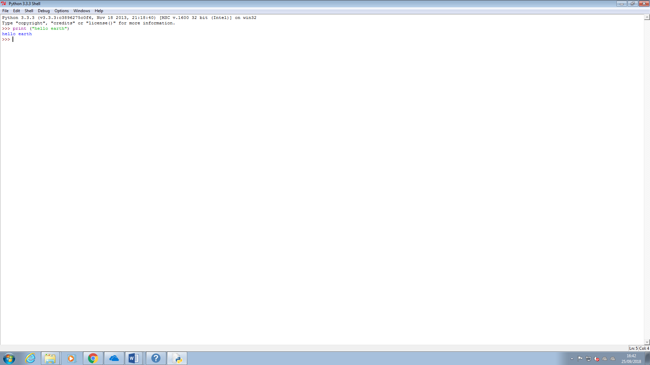

1. Write a program that produces the following output:

Hello World

I am in my ISD class right now

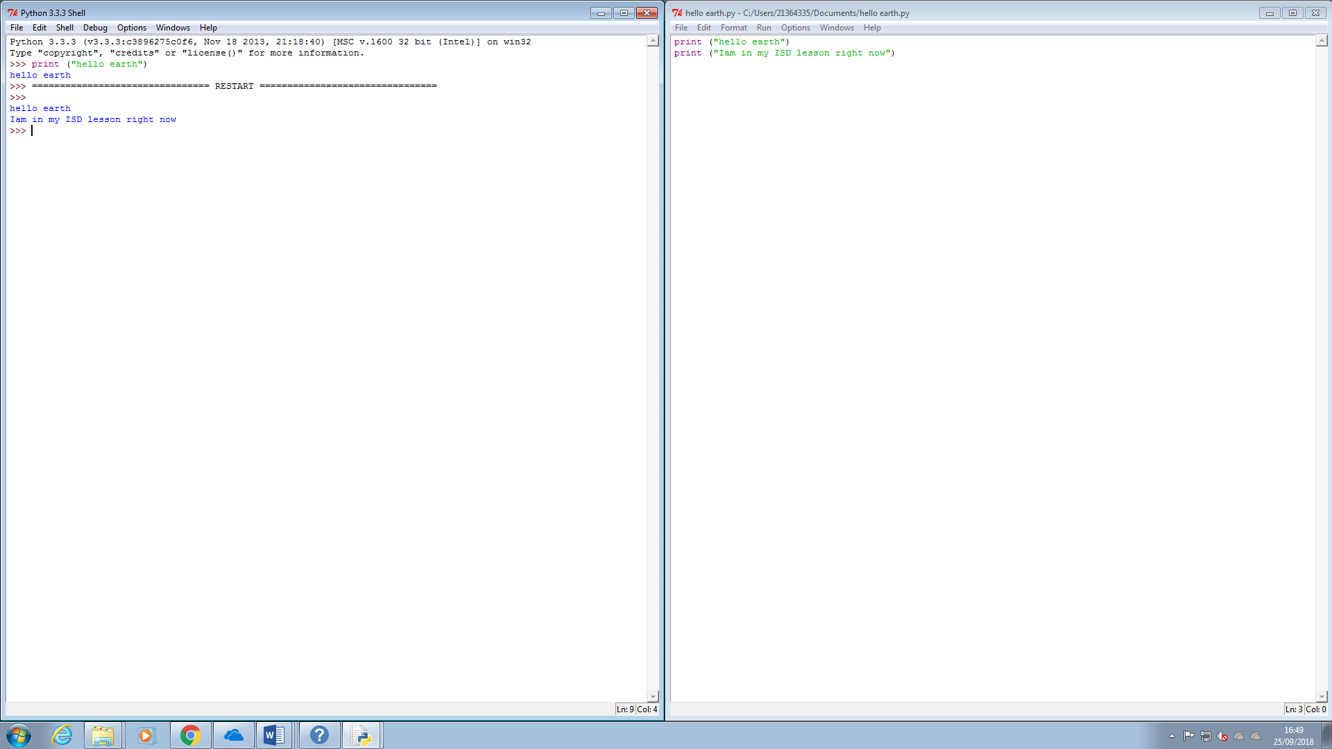

**Reminder on “Input”:**

A simple way to store variables (values) in your program is to use variables.

Variables are placeholders that can store values, like strings (words), numbers (int) etc.

To create a variable, just give it a name and an initial value, for example for a number:

number = 7

or for a String (words):

myword = “This is my word”

1. Write a program that asks the user for his/her name and produces an output like:

Hi there, what is your name?

>User input to be read<

Hello

“Username”

How are you?

